Cmpe 537

1 sayfa cover

Brief introduction: spoken descriptionlar sayesinde word ve visual attributeler arasında bağ kurmak. Visual şeyler GAN ile üretiliyor çünkü models ability to learn increased.

What is the problem, is it clearly stated: learning through drawing. Verilen örneklerle açıklanmış küp demiş onu göstermiş.

What has been done in the literature: önceden çocukların öğrenmesi araştırılmış bundan ilham alınmış. 12

24 yapılmış önceden ama bu kısım size shape vs out of ,, reach related work kısmına bak

Triplet loss is a loss function for artificial neural networks where a baseline input is compared to a positive input and a negative input.

First assume a scenario which happens most of the time with us i.e you have 2 friends(Let us call them A,B).All of you study in same class(so obviously same subjects).Usually A is Topper of the class.On the Day of results ,You scored 50 marks and other two friends(A,B) scored 95,93 marks respectively. Now when your parents came to know the results and Also assuming that they know A is topper,they now infer B is also a topper as the difference between marks of B and topper(A) is very less and you as a noob as the difference between marks of you and your topper friend is high.

We human beings do this type of classification/inference commonly most of the types by following the rule, Elements belonging to same category possess similar characteristics(In our Scenario, Marks).

Triple Loss Uses the Same logic i.e it tries to reduce the distance/deviation between similar things and at the same time tries to increase the same between different things.

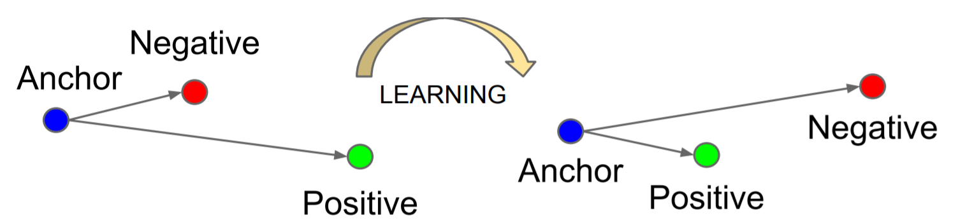

? Is this sufficiently treated? What remains to be solved? Is this clear?

A connection between lang and the knowledge learned by GAN was missing. Bunu da bunlar yapmış. Örneklerini görebiliriz a object vs teker teker ayırmış.

What are the contributions of the paper? Novelty valid mi?

Söylenene göre 500 tanesi testi geçmiş farklı farklı training methodlar uygulanmış

Increase in

The model and assumptions considered by the author(s).

Related work kısmına bakabilirsin.

The solution strategy : çözüm anlaşılıyor mu notasyonlar doğru mu

Simulation based results and 500 experiment yapılmış ortalama değerler alınmış genel bir improvement var hangi parametrelere göre????

Summary

References: <https://medium.com/@susmithreddyvedere/triplet-loss-b9da35be21b8>

GAN DISSECTION: VISUALIZING AND UNDERSTANDING GENERATIVE ADVERSARIAL NETWORKS

Jointly Discovering Visual Objects and Spoken Words from Raw Sensory Input

<https://medium.com/@jonathan_hui/gan-whats-generative-adversarial-networks-and-its-application-f39ed278ef09>

<https://medium.com/@susmithreddyvedere/triplet-loss-b9da35be21b8>

<https://cs.stanford.edu/people/jcjohns/clevr/>